Office of Student Engagement | PSU 101 | 417-836-4386 | Student Organizations, SOFAC, Leadership Programs, and FSL information
Counseling Services | Carrington Hall 311 | 417-836-5116 | Individual and group counseling as well as educational programs for cognitive, behavioral, and affective information
Event & Meeting Services | PSU 302 | 417-836-6765 | Schedule any event at the PSU or academic building, from a weekly meeting to an annual bash
Catering Services | PSU 302 | 417-836-4629 | Request and schedule food for any occasion on campus
PSU Graphic Design | PSU 1ST Floor | 417-836-4792 | Student-based design department for marketing events, services, and programs  *Special prices for Student Organizations
BearLink | PSU 114 | 417-836-4386 | Assistance in managing or registering a Student Organization
Taylor Health & Wellness | Taylor Health Center | 417-836-4030 | Full service physician’s office and pharmacy
Campus Recreation | Foster Recreation Center | 417-836-8909 | Wellness programs, intramural sports, and various sports complexes
Copy This | PSU 210 | 417-836-5808 | Full service quick copy service including digital printing, laminating, and posters
Safety & Transportation | 636 E. Elm Street | 417-836-5509 | Campus security, parking, and transportation information
Dean of Students Office | PSU 405 | 417-836-5527 | Student assistance in academics, counseling, housing, conduct, and student engagement
Multicultural Resource Center | PSU 141  Freudenberger House 17 | 417-836-5652 | Develops programs and initiatives designed to enhance the success, retention, and personal and professional development of diverse student populations
Student Government Association | PSU 123 | 417-836-5500 | Serve as a voice for students on campus while working directly with administrators, faculty, and staff

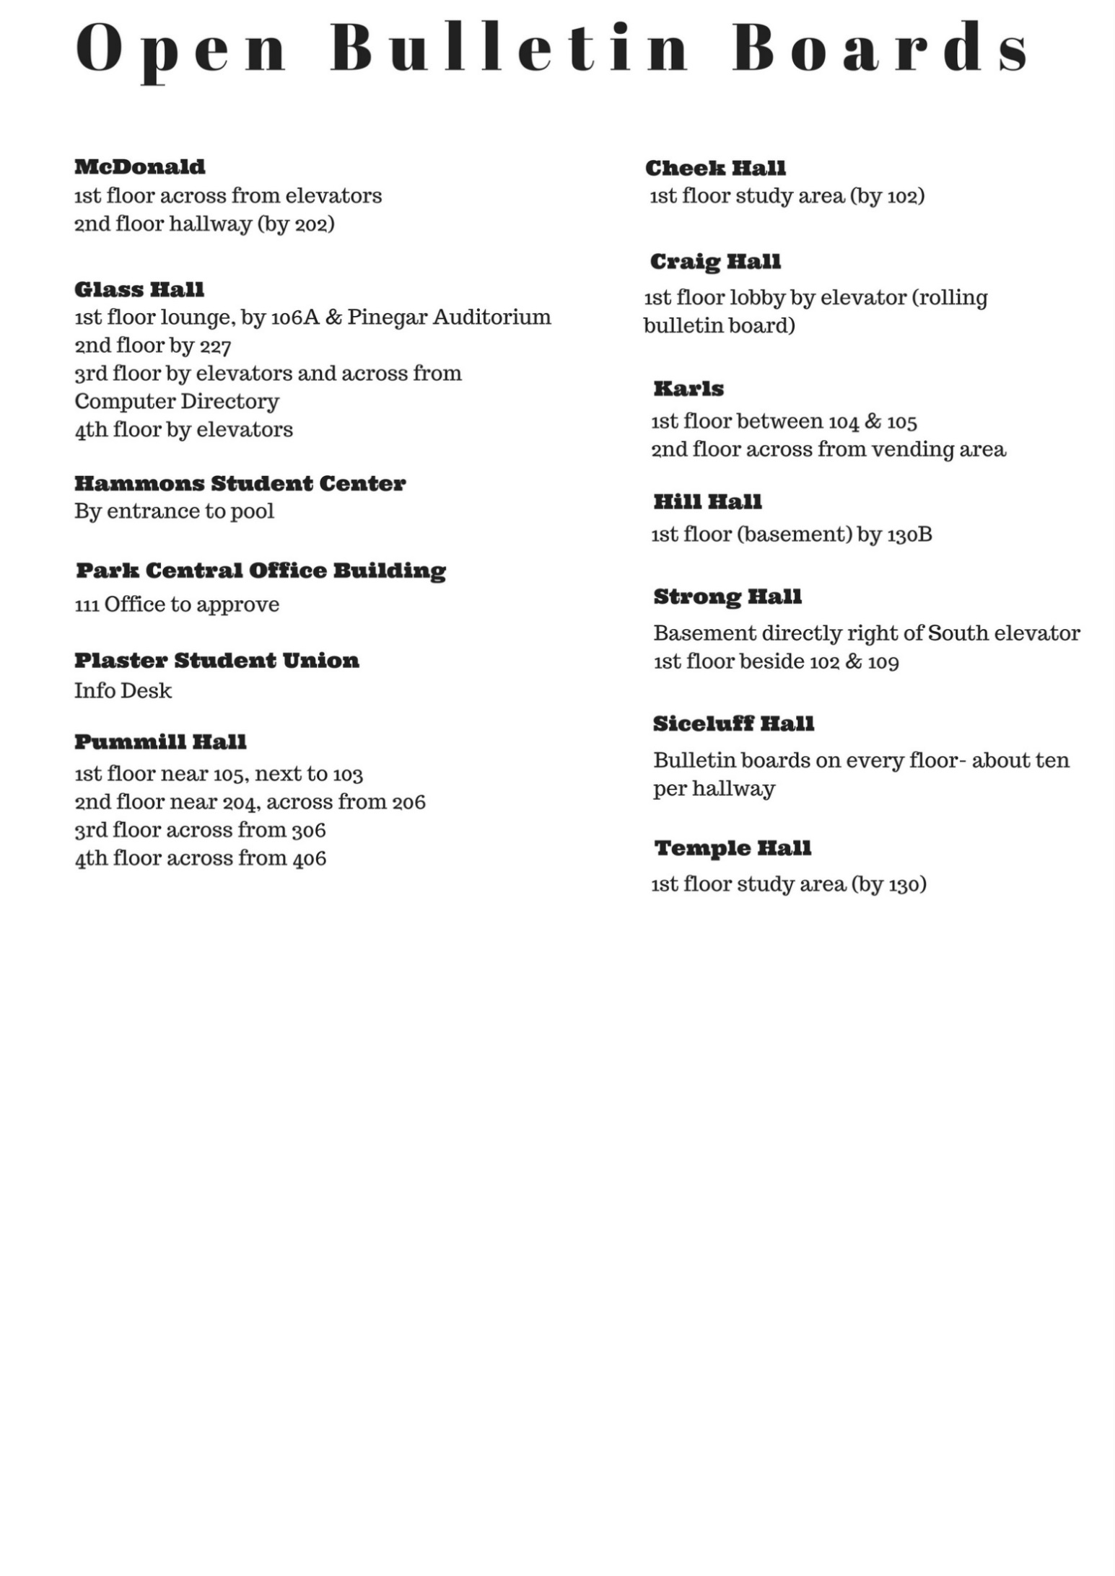

Plaster Student Union Room Reservations
Room Location | Seating Count
PSU 308 | 40-100 (depending on setup)
PSU 309 | 12
PSU 310 | 10
PSU 311 | 10
PSU 312 | 20-80 (depending on setup)
PSU 314 | 20-80 (depending on setup)
PSU 315 | 20-80 (depending on setup)
PSU 317 | 20-80 (depending on setup)
Union Club | 90-150
Ballroom West | 46-700
Ballroom East | 40-300
Grand Ballroom | 70-1000
Theater | 350-550
Parliamentary Room | 84-120

